**Phase-1 First Increment**

**Project Restaurant Finder**

**Group #13**

Katta Nikitha

Dandamudi Naga Mounika

Goli Venkata Govardhan

**Project Proposal**

**Project Title:** Restaurant Finder

**Group Members:**

Nikitha Katta

Naga Mounika Dandamudi

Venkata Govardhan Goli

**Project Goal and Objectives:**

**Goal:** Locating the nearby restaurants. Get the menu and show the nutritious information.

**Motivation:** The quotation **Health is Wealth** states the importance of health.

**Significance/Uniqueness:** App finds the nearest restaurant and show the nutritious information based on the menu.

**Objectives:** App should be able to find the restaurant. Get the menu information. Based on the food nutritious levels should be displayed.

**System Features:**

* Nutritious information of food.
* Remind the tasks.
* Suggesting the food.
* Information of intake food.

**Related Work:**

Vylegzhanina, Violetta, et al. "Helping Children Eat Well Via Mobile Software Technologies." *Proceedings of the 2nd International Workshop on Mobile Development Lifecycle*. ACM, 2014.

**Backup Project:** Zomato-Restaurant finder

**CONTENTS**

**I. Introduction**

**II. Project Goal and Objectives**

Overall goal

Specific objectives

Specific features

Significance

**III. Project Plan**

Issues

Burn Chart

Graphs of team member’s contribution

**IV. First Increment Report**

Detail Design of Features

Implementation

Deployment

Project Management

Bibliography

**I.Introduction:**

Restaurant Finder application is an android based application with a objective of finding restaurant based on the requirement which are location and the cuisine details entered by the user. The locations of various restaurants with their basic services available and the daily specials. By this application the user not only can locate the restaurants that are near by and also can make choice of best restaurant based on the rating.

This application let the user view the menu in the restaurants near by and also the nutrition value offered by the items in the menu. Health diet is important for prevent any health issues. Health Issues occur due to malnutrition which is caused due to nutrition imbalance or excessive intake of junk food. It is important for us to know the nutrition value of the food we eat, and also to what extent it is meeting the daily requirement. The main aim here in this application is to let the user find a best restaurant of his/her choice based on their location and cuisine requirements and can also know the nutrition value of the food they want to eat and can also know to how much they are meeting their daily nutritious requirement.

**II. Project Goals and Objectives:**

**Over- All Goal:**

1. The main goal of Restaurant Finder application is to find the information about the location of various restaurants near our location.
2. The route to these restaurants and their basic services available.
3. The list of items and their costs or the menu in the restaurant and also their daily specials.
4. The nutritional value and calorific value of the items in the menu.
5. Compare the nutritional value of the intake food with the available standard per day intake of different type of nutrients.

**Specific objectives:**

1. The user can locate the restaurants near by his location and routes to these restaurants.
2. The user can also view the menu or the list of items with their cost.
3. Suggest the items with high nutritional and calorific value.
4. Analyze the nutritional value of the food we eat with the standard per day intake of nutrients.

**Specific Features:**

1. Location and directions to the restaurants depending on our requirement of type of cuisine.
2. Suggesting the food with high nutritional and calorific values best suited.

**Significance:**

1. The user can make a choice of best restaurant depending on his location and the type of food he like.
2. Can maintain health diet by suggest the food with high nutritional and calorific value.

**III. Project Plan:**

**Issues:**

1. Data base connection
2. Maps Activity
3. Layouts
4. Testing
5. Register
6. Sign Up
7. Personal Information
8. Design of project
9. Use Case Diagram
10. Sequence Diagram
11. Wire Frames
12. Class Diagram

**Burndown Chart**

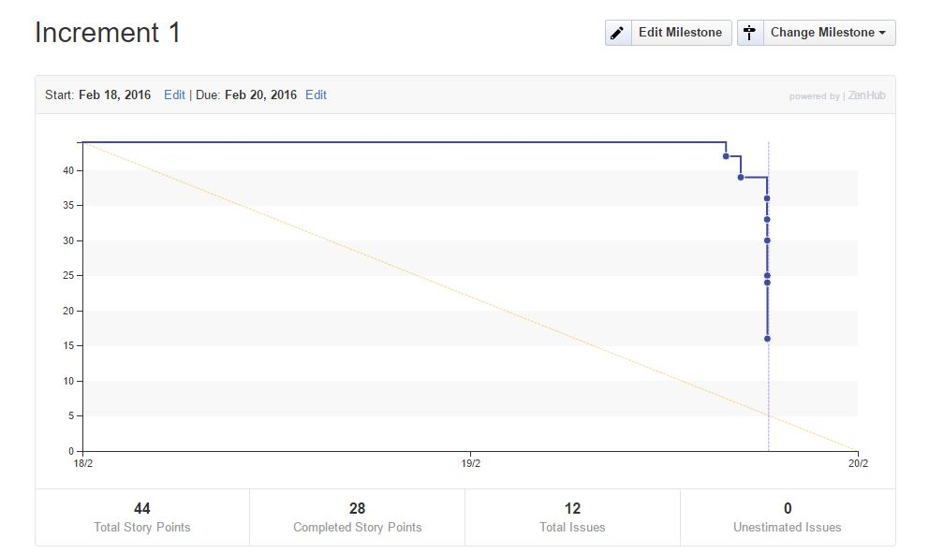

**Graphs for contribution of all the team members:**

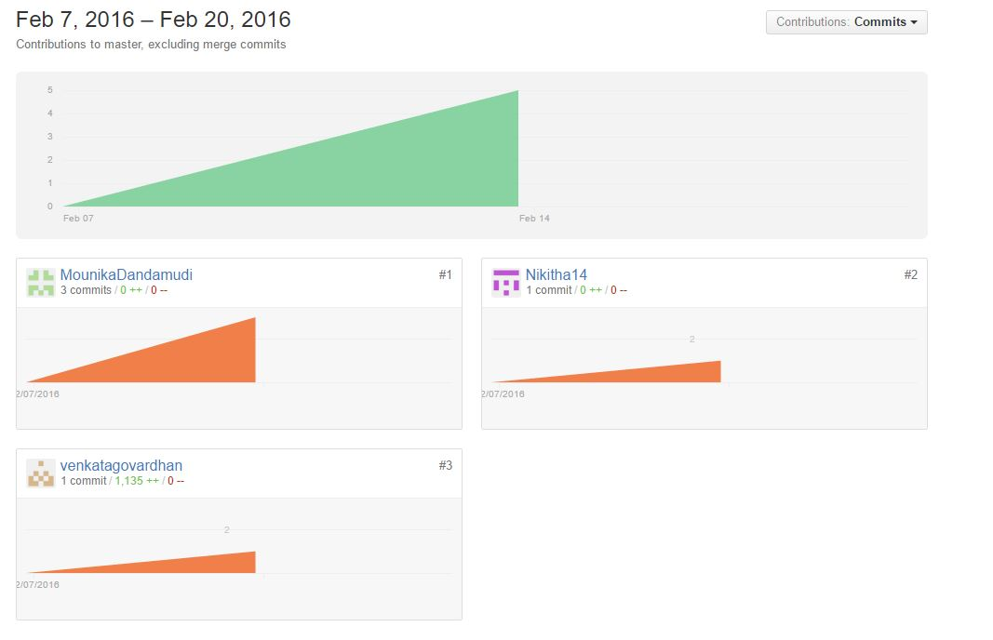

**IV.First Increment Report:**

As a part of first Increment we created Login, Register, Personal Info and Home page for the users. Any user can access Restaurant finder by login or registering in with their personal info.

A new user after registering with their personal info, can login by their entering their username and password and enter into Restaurant finder application.

After login the user's current location can be pointed out using the existing Network Provider.

**Existing Services/API:** Google Maps API, Location Services API.

**Detail Design of Features:**

**Wireframes:**

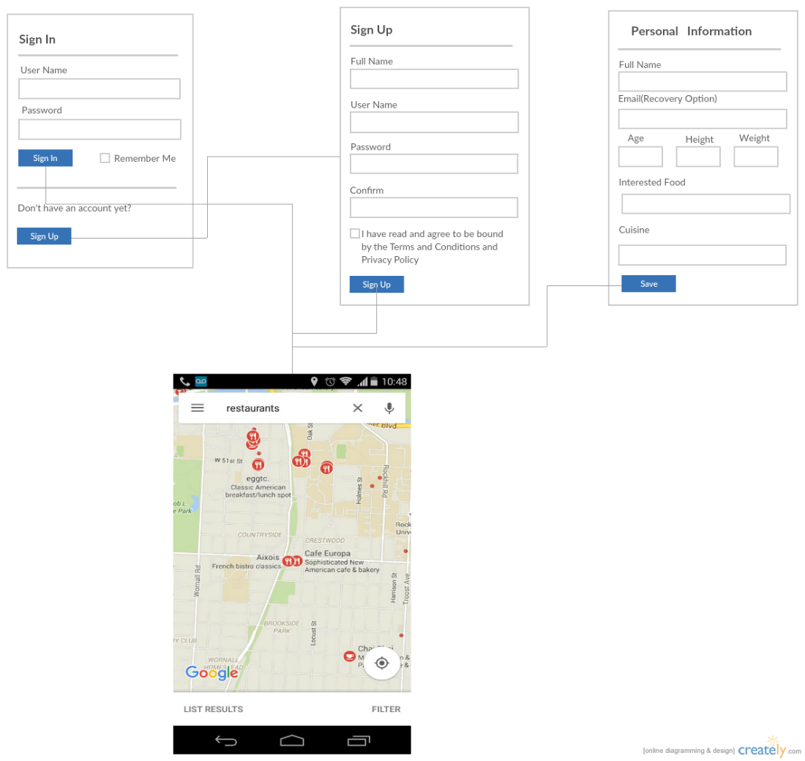

**Sequence diagram:**

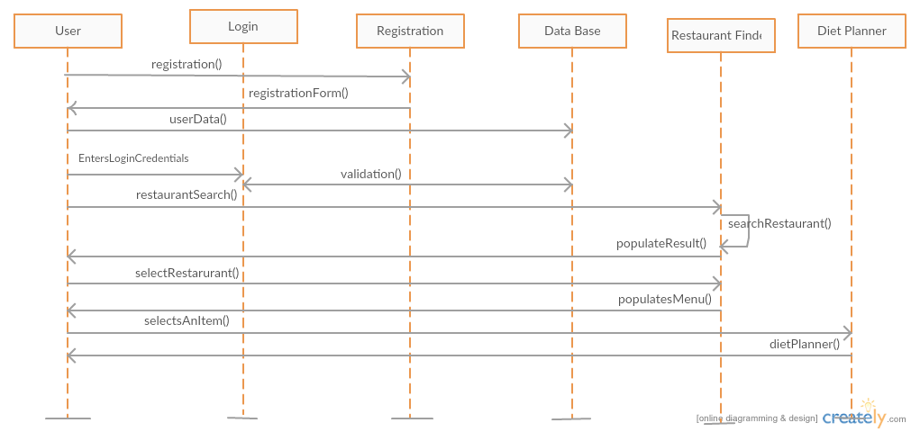

**Class diagram:**

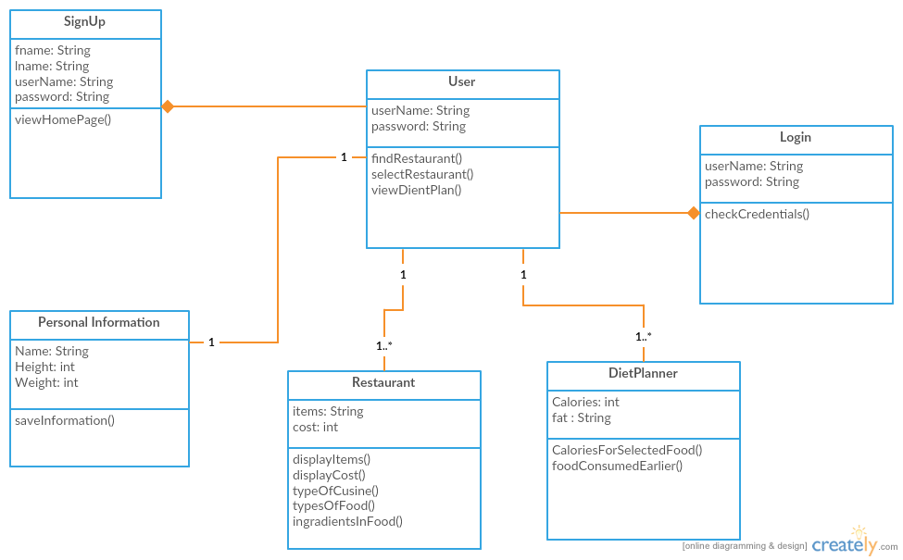

**Use Case diagram:**

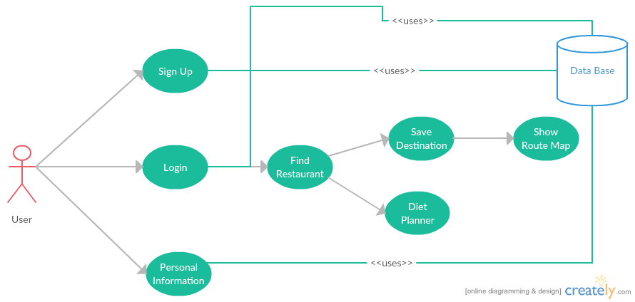

**Implementations:**

Restaurant Finder app consists of Login page, Register Page and personal info and Home page are created in android studio.

Personal info of users is stored using SQLite.

**Deployment:**

Restaurant Finder application is deployed on mobile and explained in the below screen shots.

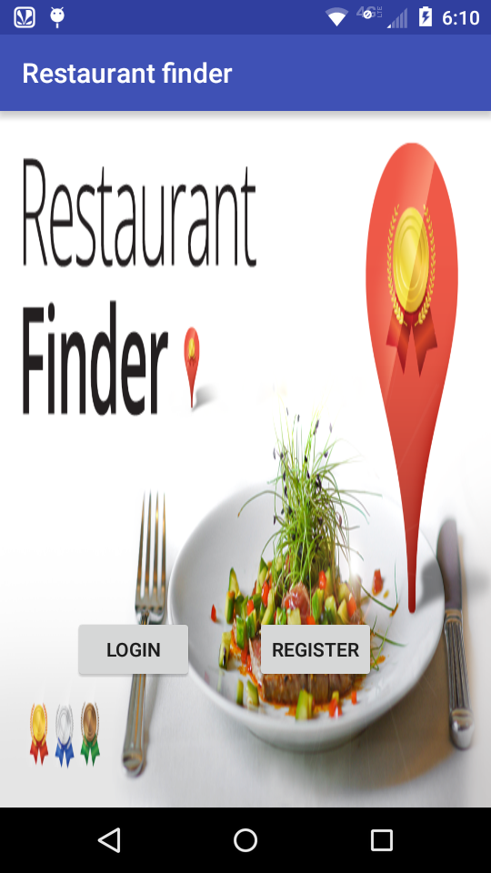 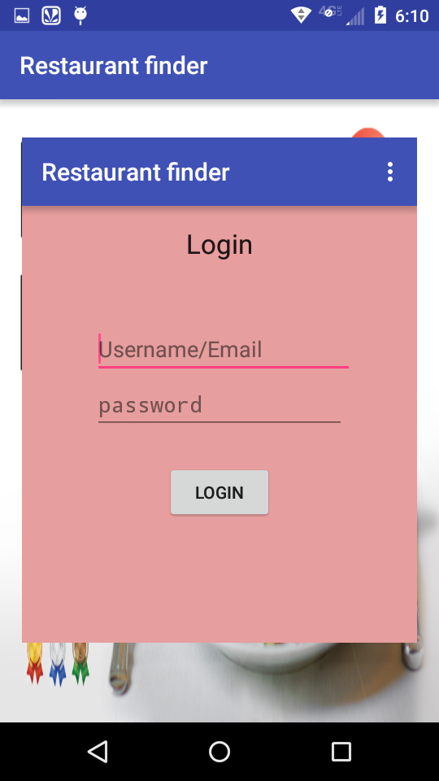

Login page of this restaurant finder app consists of Username/email and password, if the details of user are given then we can get the location of the user.

A new user has to first register to access this app, the register page or sign up consists of the personal info of the user, which on entering the info by the user we can login to the app by username/email and password.

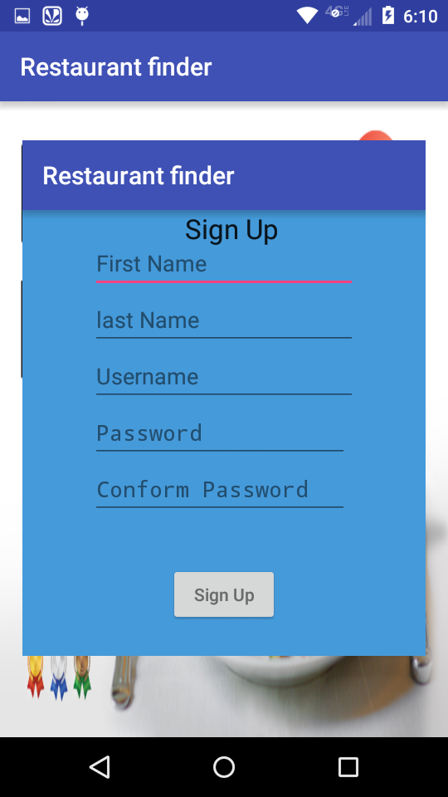 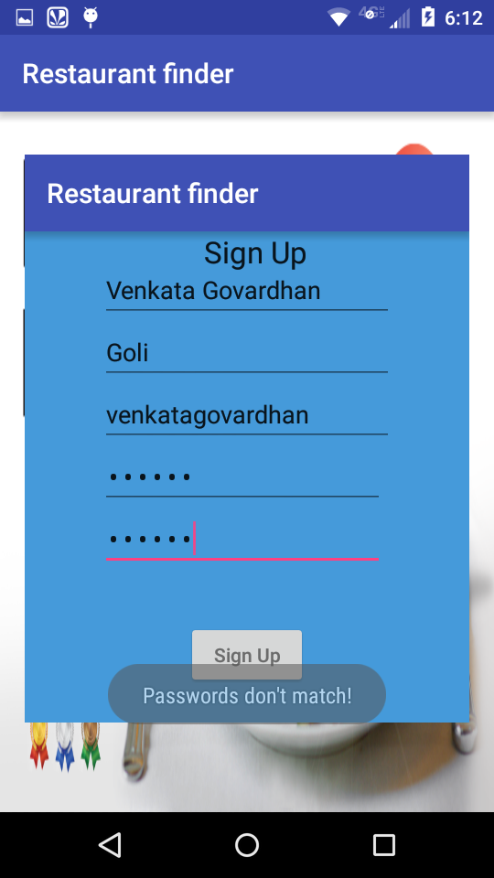

The details of the users are being stored and after signup these details can be used for login to access the restaurant finder app.

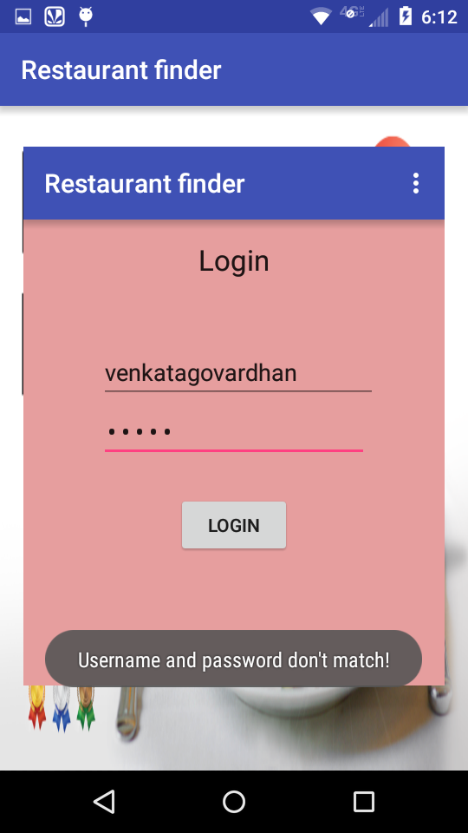 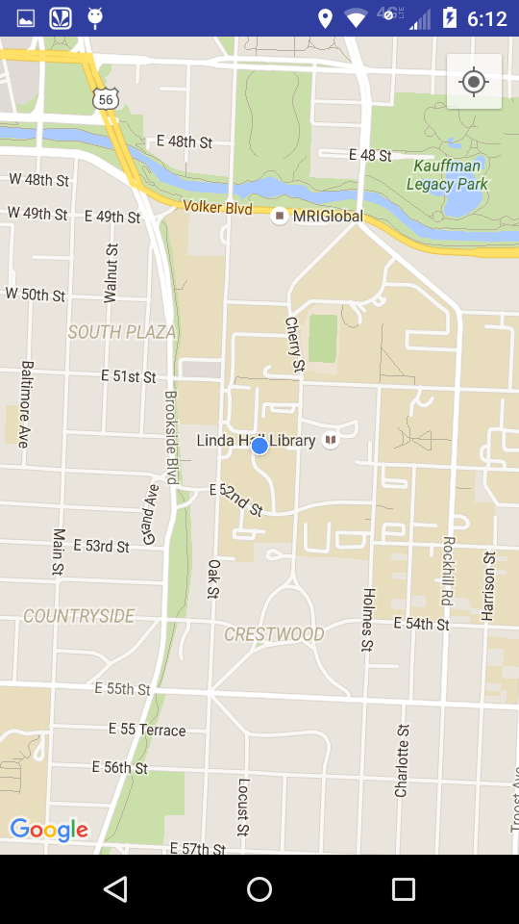

**Project Management:**

**Work completed:**

Basic design phase using class diagram, Sequence diagram and Use case diagram is completed.

The application basic design view phase using wireframes is completed.

The restaurant finder app's basic design-home, login, register and personal info pages are created.

The personal info of the users are stored using **SQLite**.

**Work to be completed:**

Call to restaurant API has to be made.

Diet planner has to be implemented further.

BMI calculator should be implemented.

**Bibliography:**

<https://console.developers.google.com>

<http://developer.android.com/tools/studio/index.html>